|  |
| --- |
| VISVESVARAYA TECHNOLOGICAL UNIVERSITY BELGAUM-590014      A MAD Mini-Project Report  On  *“Expense Tracker ”*  *A Mini-project report submitted in partial fulfilment of the requirements for the award of the degree of Bachelor of Engineering in Computer Science and Engineering of Visvesvaraya Technological University, Belgaum.*    Submitted by:  VAISHNAVI M (1DT19CS170)  VARSHITHA B S(1DT19CS173)  THEEKSHANA V(1DT18CS108)    Under the Guidance of:  Mrs. KEERTHANA SHANKAR (Asst. Prof. Dept of CSE)  AND  Mrs.CHAITRA Y R(Asst. Prof. Dept of CSE )    Department of Computer Science and Engineering  DAYANADA SAGAR ACADEMY OF TECHNOLOGY AND  MANAGAEMENT  Kanakapura Road,Udayapura, Bangalore-560 082  2020-2021 |



**DAYANADA SAGAR ACADEMY OF TECHNOLOGY AND**

**MANAGEMENT,**

Kanakapura Road,Udayapura, Bangalore -560 082

**DEPARTMENT OF COMPUTER SCIENCE & ENGINEERING**

**CERTIFICATE**

This is to certify that the Mini-Project on Database Management System (DBMS) entitled **“EXPENSE TRACKER ”** has been successfully carried out by **VAISHNAVI M (1DT19CS170)**

**VARSHITHA B S (1DT19CS173) AND THEEKSHANA V(1DT18CS108)** abonafide students of **Dayananda Sagar academy of technology and management** in partial fulfilment of the requirements for the award of degree in **Bachelor of Engineering** **in Computer Science and Engineering** of **Visvesvaraya Technological University, Belgaum** during academic year 202. It is certified that all corrections/suggestions indicated for Internal Assessment have been incorporated in the report deposited in the departmental library. The mini project report has been approved as it satisfies the academic requirements in respect of project work for the said degree.

**GUIDES:**

**Mrs. KEERTHANA SHANKAR (Asst. Prof. Dept of CSE)**

**AND**

**Mrs. CHAITRA Y R(Asst. Prof. Dept of CSE )**

**Dr. C. NANDINI**

**(Vice Principal & HOD, Dept. of CSE)**

**Examiners: Signature with Date**

**1:**

**2:**

**ACKNOWLEDGEMENT**

It gives us immense pleasure to present before you our project titled **“EXPENSE TRACKER USING JAVA and XML”.** The joy and satisfaction that accompany the successful completion of any task would be incomplete without the mention of those who made it possible. We are glad to express our gratitude towards our prestigious institution **DAYANANDA SAGAR ACADEMY OF TECHNOLOGY AND MANAGEMENT** for providing us with utmost knowledge, encouragement and the maximum facilities in undertaking this project.

We wish to express a sincere thanks to our respected principal **Dr. RAVISHANKAR M** for all their support.

We express our deepest gratitude and special thanks to **Dr.C.Nandini,** **Vice Principal &** **H.O.D, Dept.**

**Of Computer Science Engineering**, for all her guidance and encouragement.

We sincerely acknowledge the guidance and constant encouragement of our mini- project guides,

**Mrs. KEERTHANA SHANKAR (Asst. Prof. Dept of CSE) and**

**Mrs. CHAITRA Y R(Asst. Prof. Dept of CSE )**

**VAISHNAVI M (1DT19CS170)**

**VARSHITHA B S(1DT19CS173)**

**THEEKSHANA V(1DT18CS108)**

**ABSTRACT**

The project is designed for people who are finding it difficult to keep track of their expenses and savings regularly. This app allows users to record their savings and expenses and later the app also displays trends and insights in the user’s expenditure and savings through graphs and charts so that the user can easily manage their money.

The app also has many filters options so that the user can track their progress in a timely manner.

The filter options include weekly expenditure, monthly expenditure and monthly expenditure.

The Analytics section in the app derives the insights and trends from the user’s data and represents it in the form of graphs and charts.

**TABLE OF CONTENTS**

**Chapter # Chapter Name Page #**

1. **INTRODUCTION 1** 
   1. **Objective 1**
   2. **Scope of the project 1**
   3. **Functionalities 2**
   4. **Input Data and Validation**
2. **REQUIREMENTS 3** 
   1. **Hardware Requirements 3**
   2. **Software Requirements 3**

1. **DESIGN 4** 
   1. **E-R Diagram 4**

**3.1.1**  **Relational Schema** 4

**3.1.2** **Database Schema** 5

1. **IMPLEMENTATION 7** 
   1. **Introduction to Front end tool 7**
   2. **Introduction to Back-end tool 8**

**4.3 Testing 9**

1. **SOURCE CODE 9**

**6 SNAPSHOTS 10**

**7 CONCLUSION AND FUTURE WORK 24**

* 1. **Advantages 24**

**7.2 Future Enhancements 24**

**LIST OF SNAPSHOT**

#### SL # SNAPSHOT# TOPIC PAGE #

1. Snapshot 1 Home Page 16
2. Snapshot 2 Admin Login 16
3. Snapshot 3 Add Member 17
4. Snapshot 4 Allotted Work 17
5. Snapshot 5 Order List 18
6. Snapshot 6 Register 19
7. Snapshot 7 User Login 19
8. Snapshot 8 Create Events 20
9. Snapshot 9 View Event 20

**CHAPTER 1**

# INTRODUCTION

**Expense Tracker is an** everyday all busy schedule, it can be difficult to have complete control over one’s expenditure and savings. And therefore difficult to manage the flow of currency leading to unwanted expenditures and less savings. This app allows the user to track the flow of currency and spend their money in a planned and organized way. And thus having better control over income and expenditure. The app is designed to be user-friendly with the frontend designed using Java and mySQL used for backend. Google Firebase is used as a backend Platform to store all the app’s Data online. The app is still in the beta stage with more functionalities to be introduced.

.

## Objective

The main objective of the project on Event Management System is to manage the details of the Events, Activities, Organizers, Attenders, Conductors. It manages all the information about Event. The project is totally built at administrative end and this only the administrative is guaranteed the access.The purpose of the project is to build an application program to reduce the manual work for managing the Event, Activity, Payment, Organizers. It tracks all the details about the Organizers, Attendees, Conductors.

## Scope of the project

It may help collecting perfect management in details. In a very short time, the collection will be obvious, simple and sensible . it will help in Event Management System.

Our project aims at various processes of event management

* Be expandable.
* Have a good user interface.
* Satisfies user requirements.
* Easy to understand by the user and the operator.
* Delivered on schedule within the budget.
  1. **Files Functionalities**
* provides the searching facilities based on the various factors. Such as Event, Organizers, Attendees, Conductors.
* It tracks all the information of the activity, payment, etc
* Manage the information activity
* Increase efficiency of managing activity
* Integration of all records of conductors
  1. **Input Data and Validation**

* All the fields such as Event, Organizers, Conductors are validated and does not take invalid values.
* Avoiding errors in data
* Controlling amount of input.
* Preparation of all the test cases.
* Recording all the reproduced errors.
* Preparation of the possible test data with all the validation checks.
* Validations for user input.
* Commenting standard of the source

**CHAPTER 2**

# REQUIREMENTS

The requirement analysis specifies the requirements needed to develop a graphic project. In this phase, we collect the requirements needed for designing the project. The requirements collected are then analysed and carried to the next phase

## 2.1 Hardware Requirements

The Hardware requirements are very minimal and the program can be run on most of the machines.

* Processor – Pentium IV or above
* RAM – 2 GB or more
* Hard disk – 3 GB or more

## 2.2 Software Requirements

* Operating System: Windows 7 or above
* Programming Language: JavaScript ES6
* Front-end Development: HTML, CSS, JavaScript, Bootstrap
* Back-end Development: MYSQL, PHP

**CHAPTER 3**

# DESIGN

**3.1 ER DIAGRAM**

An **Entity – Relationship model** (**ER model**) describes inter-related things of interest in specific domain of knowledge. An ER model is composed of entity types (which classify the things of interest) and specifies relationships that can exist between instances of those entity types.

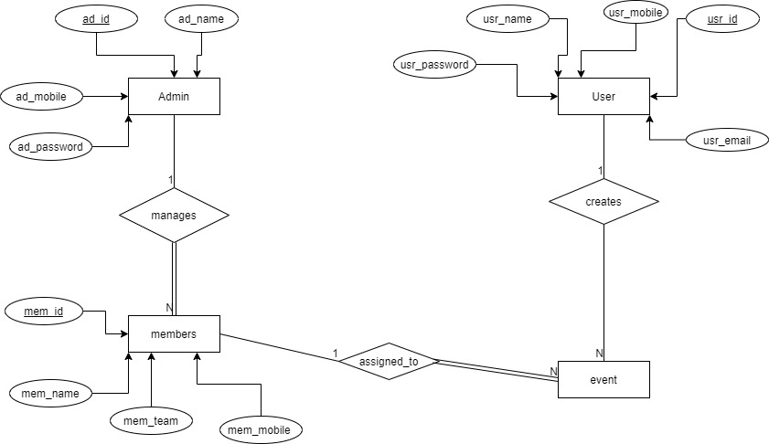

*Figure 1: Entity – Relational diagram of student performance analysis*

The ER Diagram above shows all the entities, their attributes and the relation between them. Gives the relation between a Student, Marks, and the Batch Performance These entities describe various attributes which serves as data for the database.

Here are some of the observations that are inferred from this er diagram

* admin and members have a one-to-many relationship and there is total participation of all the entities of the member table in this relation.
* members and event have a one-to-many relationship and there is total participation of all the entities of the event table in this relation.

User and event have a one-to-many relationship.

**3.1.2 Relational Schema**

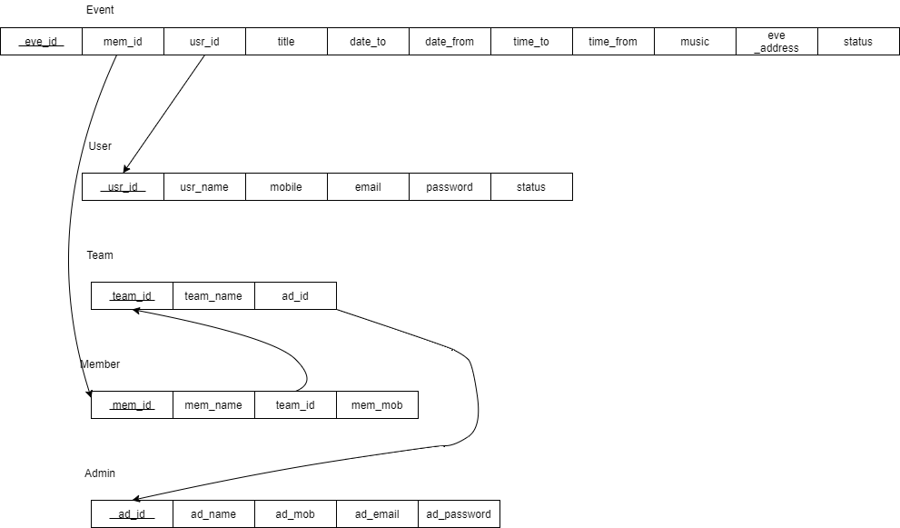**c**

The term "**schema**" refers to the organization of data as a blueprint of how the database is constructed (divided into database tables in the case of **relational** databases).

### 3.1.3 Database Schema

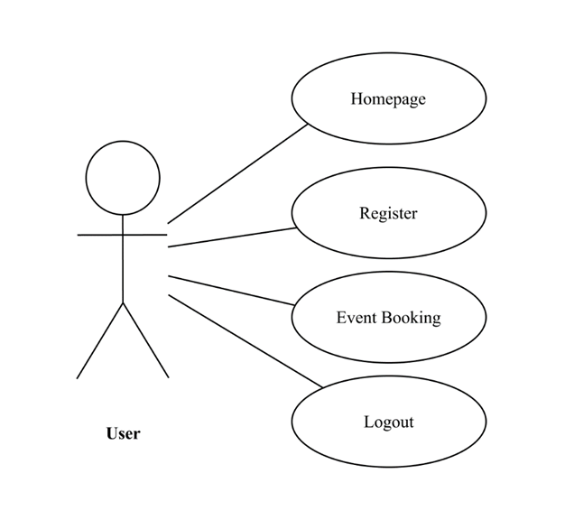

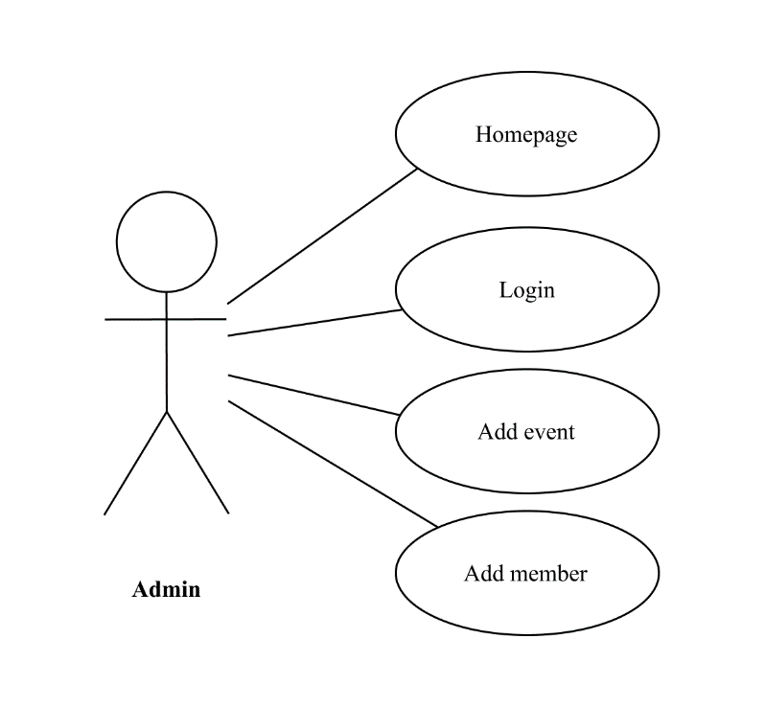

The main purpose of a use case diagram is to show who interacts with your system, and the main goals they achieve with it.

**CHAPTER 4**

**IMPLEMENTATION**

**4.1 INTRODUCTION TO FRONT END TOOL**

**4.1.1 HTML 5**

 HTML stands for Hyper Text Markup Language. It is used to design web pages using markup language. HTML is the combination of Hypertext and Markup language. Hypertext defines the link between the web pages. Markup language is used to define the text document within tag which defines the structure of web pages. HTML 5 is the fifth and current version of HTML. It has improved the markup available for documents and has introduced application programming interfaces (API) and Document Object Model (DOM).

**4.1.2 CSS**

**C**ascading **S**tyle **S**heets, fondly referred to as **CSS**, is a simply designed language intended to simplify the process of making web pages presentable. CSS allows you to apply styles to web pages. More importantly, CSS enables you to do this independent of the HTML that makes up each web page.CSS is easy to learn and understood but it provides powerful control over the presentation of an HTML document.

**4.1.3 JavaScript**

JavaScript often abbreviated as JS, is a [programming language](https://en.wikipedia.org/wiki/Programming_language) that conforms to the [ECMAScript](https://en.wikipedia.org/wiki/ECMAScript) specification. JavaScript is [high-level](https://en.wikipedia.org/wiki/High-level_programming_language), often [just-in-time compiled](https://en.wikipedia.org/wiki/Just-in-time_compilation), and [multi-paradigm](https://en.wikipedia.org/wiki/Programming_paradigm). It has [curly-bracket syntax](https://en.wikipedia.org/wiki/List_of_programming_languages_by_type#Curly-bracket_languages), [dynamic typing](https://en.wikipedia.org/wiki/Dynamic_typing), [prototype-based](https://en.wikipedia.org/wiki/Prototype-based_programming) [object-orientation](https://en.wikipedia.org/wiki/Object-oriented_programming), and [first-class functions](https://en.wikipedia.org/wiki/First-class_function). As a multi-paradigm language, JavaScript supports [event-driven](https://en.wikipedia.org/wiki/Event-driven_programming), functional, and [imperative](https://en.wikipedia.org/wiki/Imperative_programming) styles.It has [application programming interfaces](https://en.wikipedia.org/wiki/Application_programming_interface) (APIs) for working with text, dates, expressions, standard [data structures](https://en.wikipedia.org/wiki/Data_structure), and the [Document Object Model](https://en.wikipedia.org/wiki/Document_Object_Model) (DOM). However, the language itself does not include any [input/output](https://en.wikipedia.org/wiki/Input/output) (I/O), such as [networking](https://en.wikipedia.org/wiki/Computer_network), [storage](https://en.wikipedia.org/wiki/Data_storage), or [graphics](https://en.wikipedia.org/wiki/Computer_graphics) facilities, as the host environment (usually a web browser) provides those APIs.

**4.1.4 Bootstrap**

**Bootstrap** is a [free and open-source](https://en.wikipedia.org/wiki/Free_and_open-source) [CSS framework](https://en.wikipedia.org/wiki/CSS_framework) directed at responsive, [mobile- first](https://en.wikipedia.org/wiki/Responsive_web_design#Mobile_first,_unobtrusive_JavaScript,_and_progressive_enhancement) [front-end web development](https://en.wikipedia.org/wiki/Front-end_web_development). It contains [CSS](https://en.wikipedia.org/wiki/CSS)- and (optionally) [JavaScript](https://en.wikipedia.org/wiki/JavaScript)-based design templates for [typography](https://en.wikipedia.org/wiki/Web_design#Typography), [forms](https://en.wikipedia.org/wiki/Form_(HTML)), [buttons](https://en.wikipedia.org/wiki/Button_(computing)#HTML), [navigation](https://en.wikipedia.org/wiki/Web_navigation#Local_website_navigation), and other interface components.

Bootstrap is the seventh-most-starred project on [GitHub](https://en.wikipedia.org/wiki/GitHub), with more than 142,000 stars, behind [free Code Camp](https://en.wikipedia.org/wiki/FreeCodeCamp) (almost 312,000 stars) and marginally behind [Vue.js](https://en.wikipedia.org/wiki/Vue.js) framework.

**4.2 INTRODUCTION TO BACK-END TOOL**

**4.2.1 PHP**

PHP is a [general-purpose](https://en.wikipedia.org/wiki/General-purpose_programming_language) [scripting language](https://en.wikipedia.org/wiki/Scripting_language) especially suited to [web development](https://en.wikipedia.org/wiki/Web_development). It was originally created by Danish-Canadian [programmer](https://en.wikipedia.org/wiki/Programmer) [Rasmus Lerdorf](https://en.wikipedia.org/wiki/Rasmus_Lerdorf)  In 1994. The PHP [reference implementation](https://en.wikipedia.org/wiki/Reference_implementation) is now produced by The PHP Group. PHP originally stood for *Personal Home Page*, but it now stands for the [recursive initialism](https://en.wikipedia.org/wiki/Recursive_initialism) *PHP: Hypertext Pre-processor*.

PHP code is usually processed on a [web server](https://en.wikipedia.org/wiki/Web_server) by a PHP [interpreter](https://en.wikipedia.org/wiki/Interpreter_(computing)) implemented as a module, a [daemon](https://en.wikipedia.org/wiki/Daemon_(computing)) or a [Common Gateway Interface](https://en.wikipedia.org/wiki/Common_Gateway_Interface) ([CGI](https://en.wikipedia.org/wiki/Computer-generated_imagery)) executable. On a web server, the result of the interpreted and executed PHP code – which may be any type of data, such as generated [HTML](https://en.wikipedia.org/wiki/HTML) or binary image data – would form the whole or part of an [HTTP](https://en.wikipedia.org/wiki/Hypertext_Transfer_Protocol) response. Various [web template systems](https://en.wikipedia.org/wiki/Web_template_system), web [content management systems](https://en.wikipedia.org/wiki/Content_management_system), and [web frameworks](https://en.wikipedia.org/wiki/Web_framework) exist which can be employed to orchestrate or facilitate the generation of that response. Additionally, PHP can be used for many programming tasks outside of the web context, such as standalone [graphical applications](https://en.wikipedia.org/wiki/Graphical_user_interface)[[9]](https://en.wikipedia.org/wiki/PHP#cite_note-9) and robotic [drone](https://en.wikipedia.org/wiki/Unmanned_aerial_vehicle) control.Arbitrary PHP code can also be interpreted and executed via [command-line interface](https://en.wikipedia.org/wiki/Command-line_interface) (CLI).

The standard PHP interpreter, powered by the [Zend Engine](https://en.wikipedia.org/wiki/Zend_Engine), is [free software](https://en.wikipedia.org/wiki/Free_software) released under the [PHP License](https://en.wikipedia.org/wiki/PHP_License). PHP has been widely ported and can be deployed on most web servers on almost every [operating system](https://en.wikipedia.org/wiki/Operating_system) and [platform](https://en.wikipedia.org/wiki/Computing_platform), free of charge.

The PHP language evolved without a written [formal specification](https://en.wikipedia.org/wiki/Formal_specification) or standard until 2014, with the original implementation acting as the [*de facto*](https://en.wikipedia.org/wiki/De_facto) standard which other implementations aimed to follow. Since 2014, work has gone on to create a formal PHP specification.

**4.2.2 MySQL**

MySQL is [free and open-source software](https://en.wikipedia.org/wiki/Free_and_open-source_software) under the terms of the [GNU General Public License](https://en.wikipedia.org/wiki/GNU_General_Public_License), and is also available under a variety of [proprietary](https://en.wikipedia.org/wiki/Proprietary_software) licenses. MySQL was owned and sponsored by the [Swedish](https://en.wikipedia.org/wiki/Sweden) company [MySQL AB](https://en.wikipedia.org/wiki/MySQL_AB), which was bought by [Sun Microsystems](https://en.wikipedia.org/wiki/Sun_Microsystems) (now [Oracle Corporation](https://en.wikipedia.org/wiki/Oracle_Corporation)). In 2010, when Oracle acquired Sun, Widenius [forked](https://en.wikipedia.org/wiki/Fork_(software_development)) the [open-source](https://en.wikipedia.org/wiki/Open-source) MySQL project to create [MariaDB](https://en.wikipedia.org/wiki/MariaDB).

**4.3 Testing**

Testing is the process of executing a program to find the errors.A good test has the high probability of finding a yet undiscovered error. A test is vital to the success of the system. System test makes a logical assumption that if all parts of the system are correct, then goal will be successfully achieved.

**4.3.1 TYPES OF TESTING**

4.2.1 Module Testing.

4.2.2 Integration Testing.

**4.3.2 Module Testing**

Module testing is the testing of complete code objects as produced by the complier when built from source.A library may be composed of a single complied object or several complied objects. There is only a slight difference between unit testing and module testing. Modules are fully formed chunks of coherent source code that can typically be tested by driving a few functions signatures with various stimuli. On the other hand, unit testing (which is considered as part of the implementation phase for this software development process) may involve testing one small part of a function that will never formally implement any function interface.

As a result of modules being more self-contained, module testing will likely require less testing infrastructure such as test harness and test stubs. The testing of modules could perhaps even be automated so that they can be included in regression test suites or a acceptance test suites.

**4.3.3 Integration Testing**

Integration testing (sometimes called integration and testing, abbreviated I&T) is the phase in software testing in which individual software modules are combined and tested as a group. It occurs after unit testing and before validation testing. Integration testing takes as its input modules that have been unit tested, groups them in larger aggregates, applies tests defined in an integration test plan to those aggregates, and delivers as its output the integrated system ready for system testing.

|  |  |  |  |  |  |
| --- | --- | --- | --- | --- | --- |
| **Test Case Id** | **Description** | **Input Data** | **Expected Output** | **Actual Output** | **Status** |
| 1 | mepage | Click on Buttons | Redirect to the Expected page | Button working | Pass |
| 2 | Login | Userid & password | Redirect to page | User homepage | Pass |
| 3 | Register | Input details | Register the data | Create a new id | Pass |
| 4 | Event booking | Input details | Confirm booking | Confirm message | Pass |
| 5 | Add member | Input member details | Confirm | Confirm | Pass |

**CHAPTER 5**

**SOURCE CODE**

**5.1 DATABASE CONCEPT USED**

1. PHP
2. MySQL

**5.2 MODULES**

1. **Home Page**

<?php require_once"dbconfig.php";?>

<!DOCTYPE html>

<html lang="en">

<meta http-equiv="content-type" content="text/html;charset=UTF-8" />

<head>

<meta charset="utf-8">

<title>Event's! Bootstrap Template</title>

<meta content="width=device-width, initial-scale=1.0" name="viewport">

<meta content="" name="keywords">

<meta content="" name="description">

<!-- Favicons -->

<link href="img/favicon.png" rel="icon">

<link href="img/apple-touch-icon.png" rel="apple-touch-icon">

<!-- Google Fonts -->

<link href="https://fonts.googleapis.com/css?family=Open+Sans:300,300i,400,400i,700,700i|Montserrat:300,400,500,700" rel="stylesheet">

<!-- Bootstrap CSS File -->

<link href="lib/bootstrap/css/bootstrap.min.css" rel="stylesheet">

<!-- Libraries CSS Files -->

<link href="lib/font-awesome/css/font-awesome.min.css" rel="stylesheet">

<link href="lib/animate/animate.min.css" rel="stylesheet">

<link href="lib/ionicons/css/ionicons.min.css" rel="stylesheet">

<link href="lib/owlcarousel/assets/owl.carousel.min.css" rel="stylesheet">

<link href="lib/lightbox/css/lightbox.min.css" rel="stylesheet">

<!-- Main Stylesheet File -->

<link href="css/style.css" rel="stylesheet">

<style>

body{

background-img: img/background.jpg !important;

}

</style>

</head>

<body>

<!--==========================

Header

============================-->

<header id="header" class="fixed-top">

<div class="container">

<div class="logo float-left">

<!-- Uncomment below if you prefer to use an image logo -->

<!-- <h1 class="text-light"><a href="#header"><span>Event's!</span></a></h1> -->

<h1 style="font-weight:bold">Event Management</h1>

</div>

<?php include"nav.php";?>

</div>

</header><!-- #header -->

<!--==========================

Intro Section

============================-->

<section id="intro" class="clearfix">

<div class="container">

<div class="intro-img">

<img src="" alt="" class="img-fluid">

</div>

<div class="intro-info">

<h2>We provide<br><span>solutions</span><br>for your Events!</h2>

<div>

</div>

</div>

</div>

</section><!-- #intro -->

<!--==========================

Footer

============================-->

<footer id="footer">

<div class="footer-top">

<div class="container">

<div class="row">

<div class="col-lg-4 col-md-6 footer-info">

<h3></h3>

</div>

<div class="col-lg-3 col-md-6 footer-contact">

<div class="social-links">

<a href="#" class="twitter"><i class="fa fa-twitter"></i></a>

<a href="#" class="facebook"><i class="fa fa-facebook"></i></a>

<a href="#" class="instagram"><i class="fa fa-instagram"></i></a>

<a href="#" class="google-plus"><i class="fa fa-google-plus"></i></a>

<a href="#" class="linkedin"><i class="fa fa-linkedin"></i></a>

</div>

</div>

</div>

</div>

</div>

<div class="container">

<div class="copyright">

</div>

</div>

</footer><!-- #footer -->

<a href="#" class="back-to-top"><i class="fa fa-chevron-up"></i></a>

<!-- Uncomment below i you want to use a preloader -->

<!-- <div id="preloader"></div> -->

<!-- JavaScript Libraries -->

<script src="lib/jquery/jquery.min.js"></script>

<script src="lib/jquery/jquery-migrate.min.js"></script>

<script src="lib/bootstrap/js/bootstrap.bundle.min.js"></script>

<script src="lib/easing/easing.min.js"></script>

<script src="lib/mobile-nav/mobile-nav.js"></script>

<script src="lib/wow/wow.min.js"></script>

<script src="lib/waypoints/waypoints.min.js"></script>

<script src="lib/counterup/counterup.min.js"></script>

<script src="lib/owlcarousel/owl.carousel.min.js"></script>

<script src="lib/isotope/isotope.pkgd.min.js"></script>

<script src="lib/lightbox/js/lightbox.min.js"></script>

<!-- Contact Form JavaScript File -->

<script src="contactform/contactform.js"></script>

<!-- Template Main Javascript File -->

<script src="js/main.js"></script>

<script>if( window.self == window.top ) { (function(i,s,o,g,r,a,m){i['GoogleAnalyticsObject']=r;i[r]=i[r]||function(){ (i[r].q=i[r].q||[]).push(arguments)},i[r].l=1*new Date();a=s.createElement(o), m=s.getElementsByTagName(o)[0];a.async=1;a.src=g;m.parentNode.insertBefore(a,m) })(window,document,'script','../../../../www.google-analytics.com/analytics.js','ga'); ga('create', 'UA-55234356-4', 'auto'); ga('send', 'pageview'); } </script>

</body>

</html>

**5.3 Functional Requirements**

**R1: Registration**

Description: To enter into this App, user has to register himself first. Requirements of registration are first name, last name, user name, email-id, password, confirm password etc.

Input: User Details

Output: Filled Registration Details.

Processing: User details are checked with database. Password constraint is checked as per validation.

**R2: User Login**

Description: The System provides facility to login into the system.

Input: Enter username and password

Output: User Profile page

Processing: The system will check the input of user and if valid then login is done. Otherwise, user will be asked to re-enter the username and password.

**R3: Select the event**

Description: The user can select the event.

Input: Main event, Sub event, Enrolment number, Add team member.

Output: Event selected Successfully, also see all detail and delete also.

Processing: The system will add selected data into database.

**R4: Admin panel**

Description: The Admin can add manager, main event, sub-event also.

Input: main event, sub-event, manager.

Output: Add successfully in database.

Processing: The system will add selected data into database.

**R5: Logout**

Description: The system provides the facility to logout

Input: Select logout option

Output: Logout from the system

**CHAPTER 6**

**SNAPSHOTS**

This is the landing page that is this is what the user sees when he first visits the website’s url. It shows basic information about the website.



Snapshot 1: “Home Page”

This is admin login page. From here the admin can login to the admin section of the website.

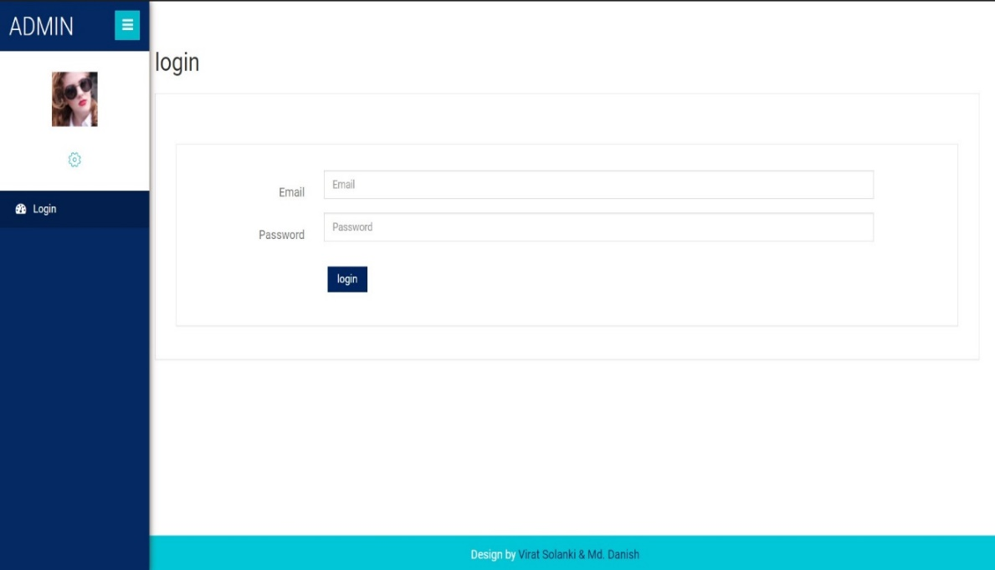

Snapshot 2: “Admin login”

In this page admin can add team members and assign them to a specific team.

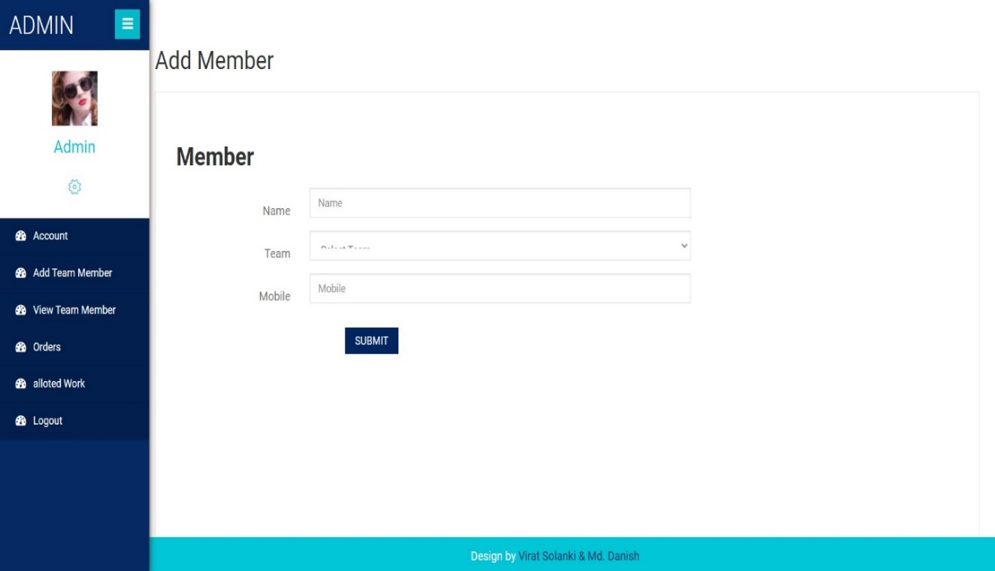

Snapshot 3: “Add Member”

From this page the admin can see which team has been allotted to which event.

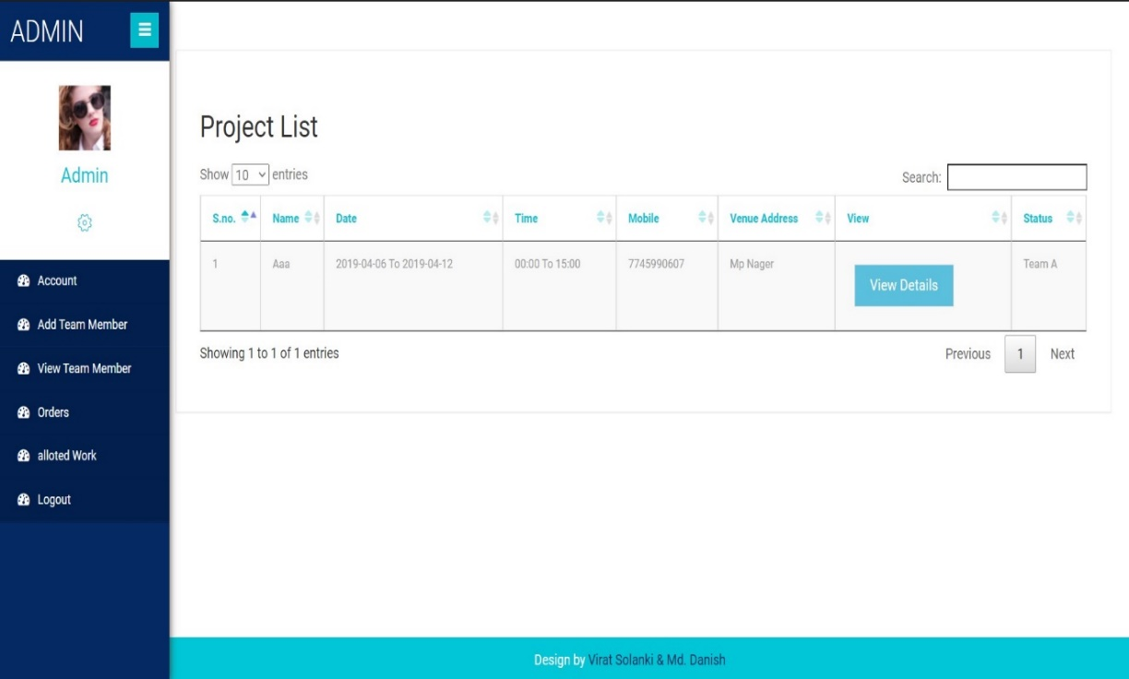

Snapshot 4: “Allotted work”

Here the admin can see the details of all the bookings that have been made by the users and also here he can assign a team to an event.

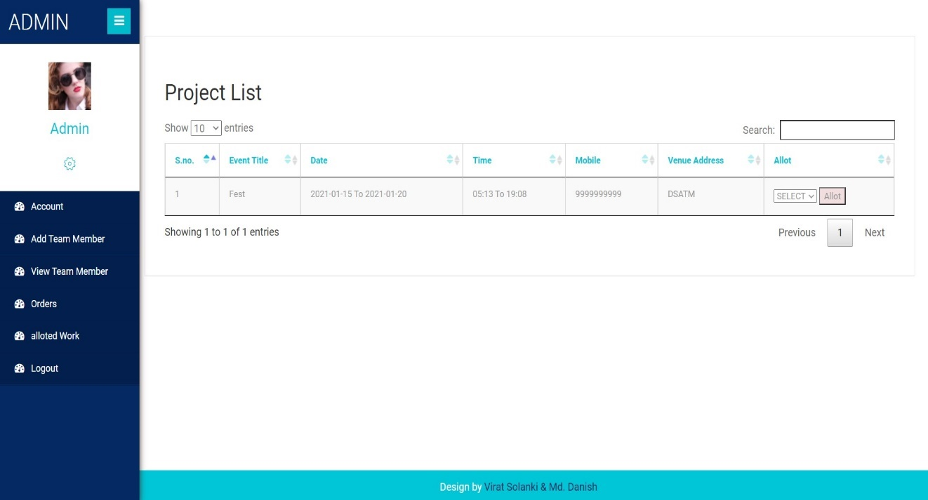

Snapshot 5: “Order list”

When the user clicks on the register button this page is shown, from here a user can register for our website by providing their details.

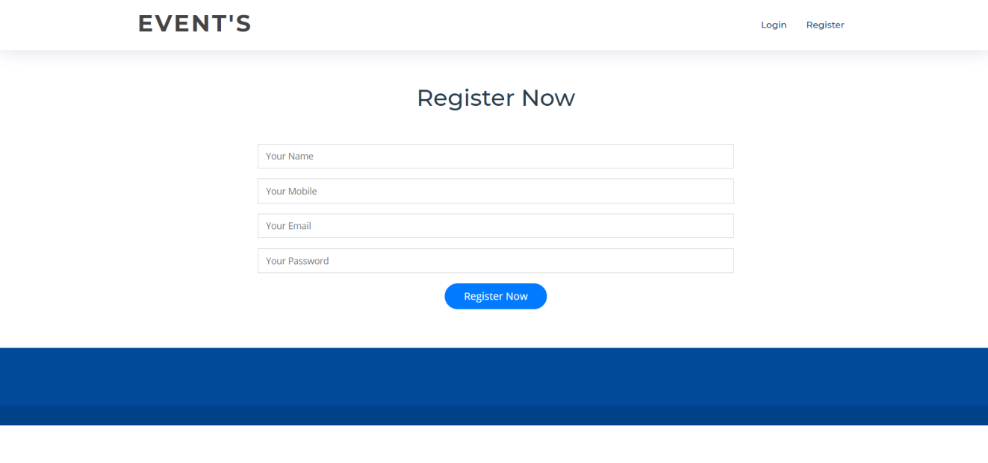

Snapshot 6: “Register”

After the user has registered for the website, they can then login to the website by providing their email and their password.

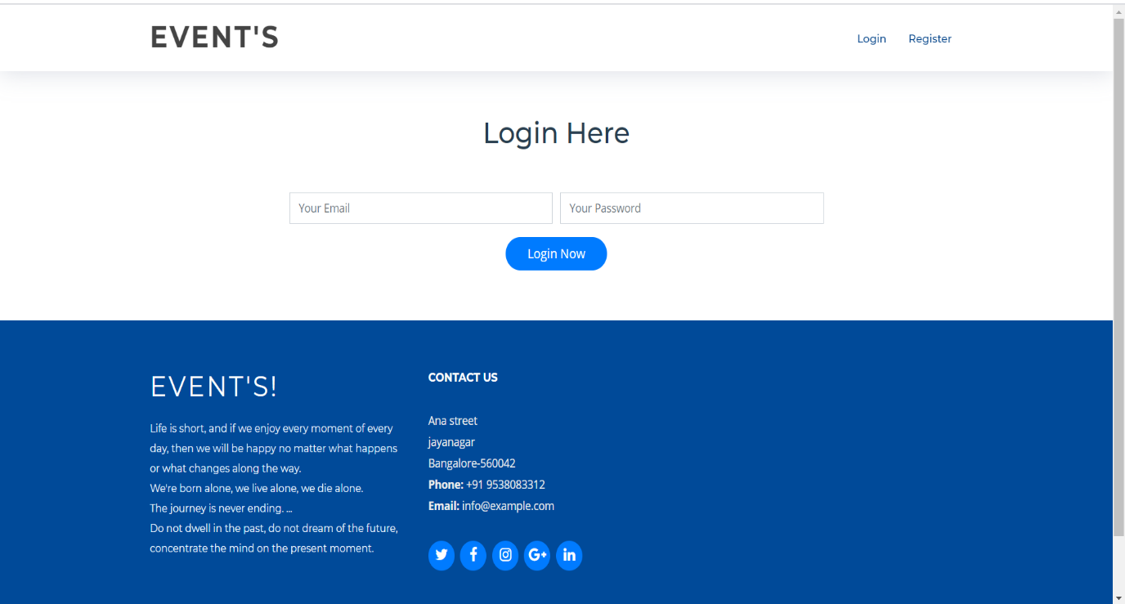

Snapshot 7: “user login”

This is the create events page. Here user can create new events by filling the form with appropriate information.

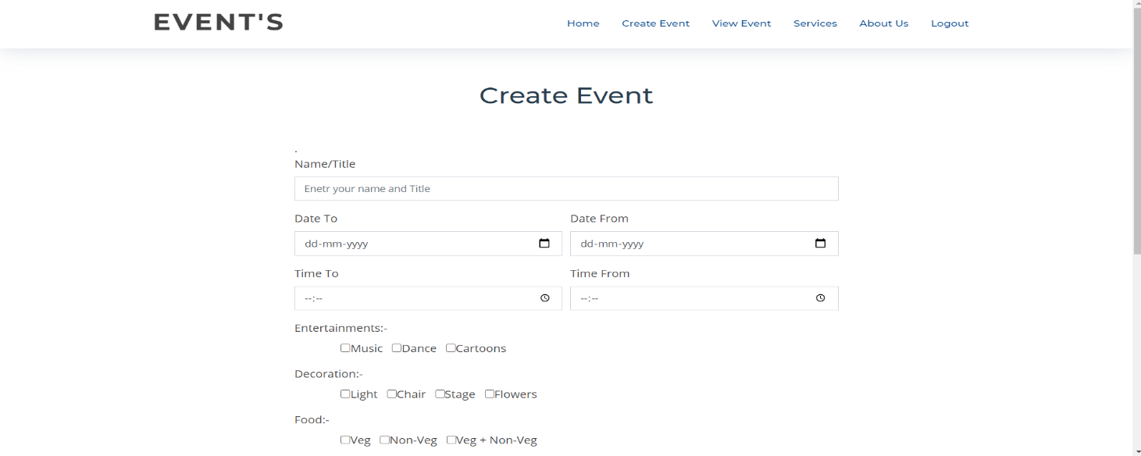

Snapshot 8: “Create Event”

This is the view events page. From here the user can view the events that he created and also see whether a team has been assigned to the event or not.

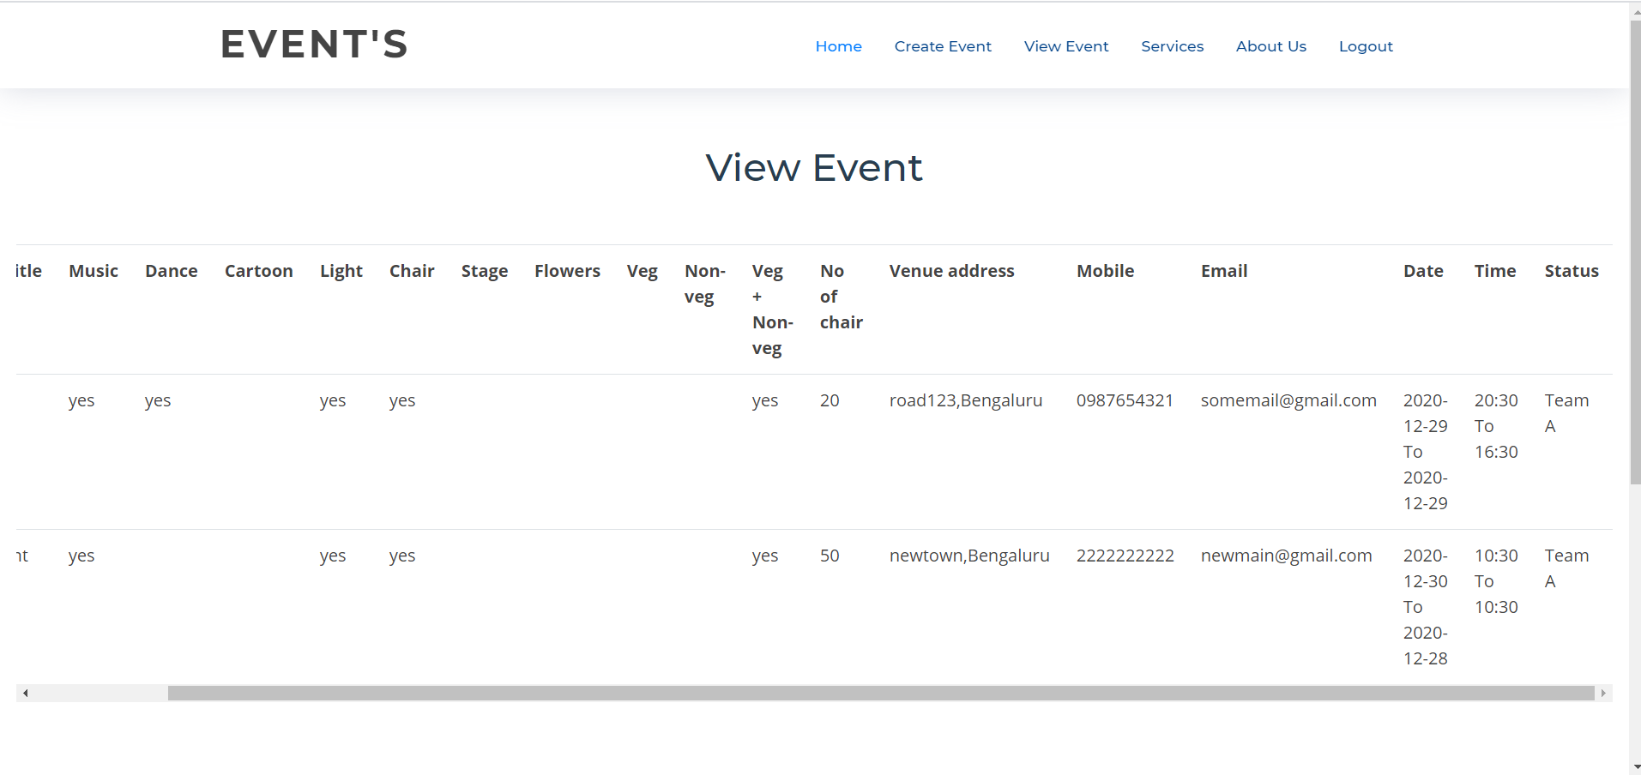

Snapshot 9: “View Event”

**CHAPTER 7**

**CONCLUSION AND FUTURE ENHANCEMENTS**

To conclude the description about the project: The project developed using HTML, CSS, JavaScript, Node.js and MySQL on the requirement specification of the user and the analysis of the existing system, with flexibility for future enhancement.

The expanded functionality of today’s software requires an appropriate approach towards software development. The Student Performance Analysis is designed for Teachers and faculties whom want to check the records of the student and for those who want to see the performance of the branch.

In future enhancements, Teachers and faculties would have the option to render the database by inserting the records through the website, this software can be converted into a mobile application ( most probably using PWA) which further reduces the need to visit the website.

**BIBLIOGRAPHY**

**REFERENCES**

[1] Google.

[2] https://stackoverflow.com/

[3] https://www.geeksforgeeks.org/

[4] https://www.w3schools.com/php/func_mysqli_connect.asp

### [5] https://developer.mozilla.org/en-US/docs/Web/php

**PERSONAL DETAILS:**

**NAME: VAISHNAVI M**

**USN: 1DT19CS170**

#### SEMISTER AND SECTION: 6th SEM &'C' SEC

**COLLEGE: DAYANANDA SAGAR ACADEMY OF TECHNOLOGY AND MANAGEMENT**

**EMAIL ID: vaishnavivish027@gmail.com**

**NAME: VARSHITHA B S**

**USN: 1DT19CS173**

**SEMESTER AND SECTION: 6th SEM & ‘C’ SEC**

**COLLEGE: DAYANANDA SAGAR ACADEMY OF TECHNOLOGY AND MANAGEMENT**

**EMAIL ID: varshithasiddachari@gmail.com**

**NAME: THEEKSHANA V**

**USN: 1DT18CS108**

**SEMESTER AND SECTION: 5th SEM & ‘C’ SEC**

**COLLEGE: DAYANANDA SAGAR ACADEMY OF TECHNOLOGY AND MANAGEMENT**

**EMAIL ID: theekshu12@gmail.com**